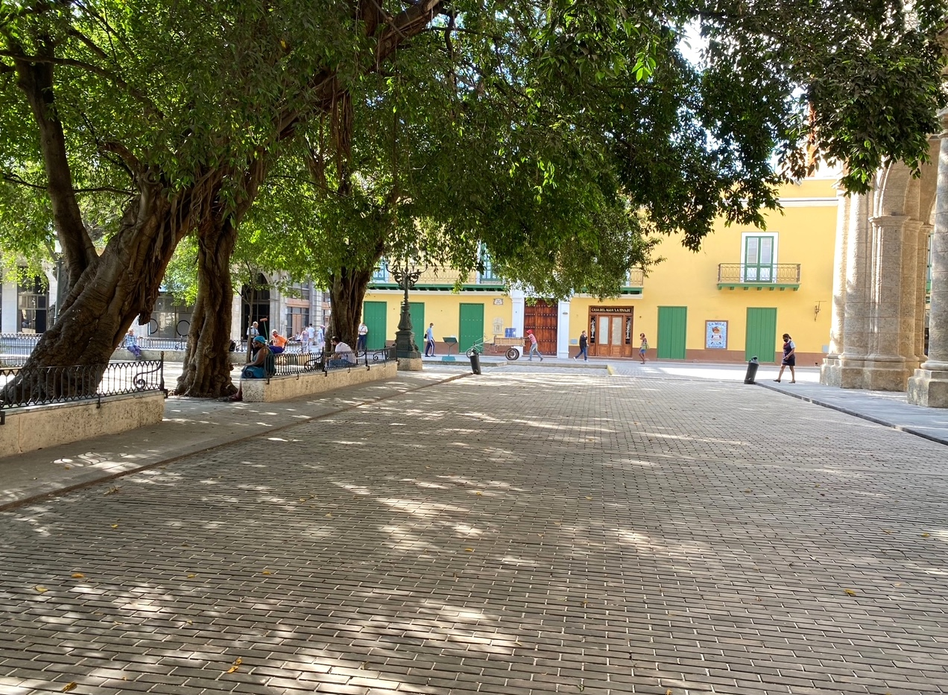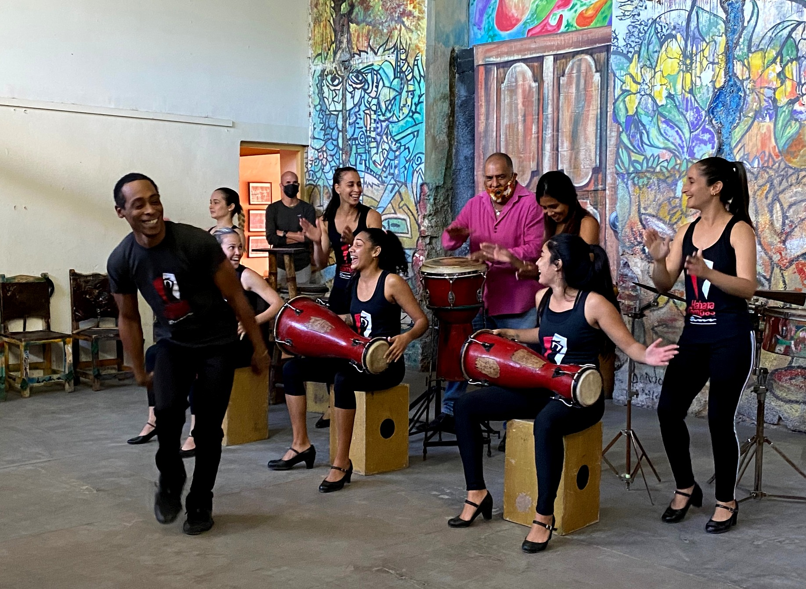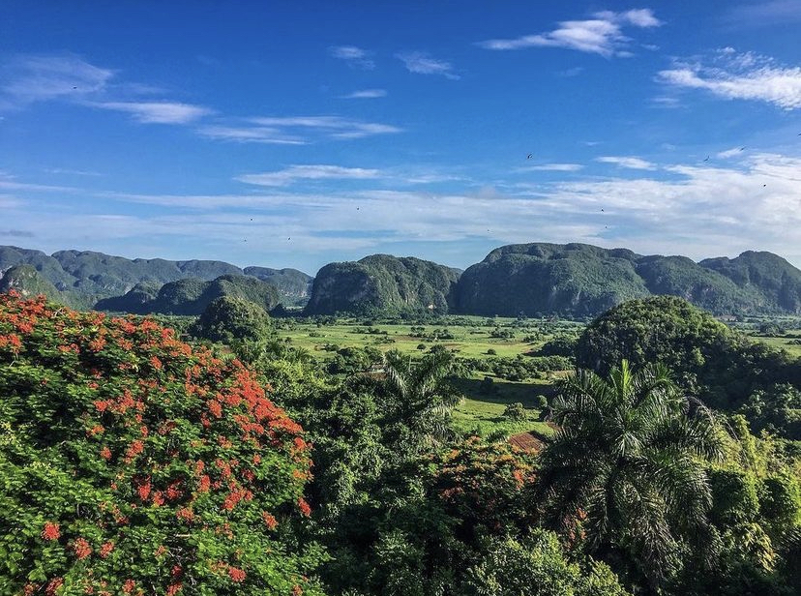

**¡¡¡TRAVEL TO CUBA IS OPENING UP ONCE AGAIN!!!**

**Join IFAM and Peggy Gaustad on a trip to Havana and the Valley of Viñales**

**January 11 - 18, 2023**

**Trip Highlights – Seven nights and eight days**

With an emphasis on the folk art traditions of Cuba, we will have a very in depth and personal exposure to some of the country's leading artists. We will experience the rich cultural fabric of this dynamic city which is undergoing significant change, while at the same time retaining an atmosphere of days gone by. We will be treated to private dance and musical performances, lectures, and studio visits. Our evenings will find us dining in the finest of Havana's restaurants in a city that is enjoying a culinary renaissance.

We will have a private tour of the fabulous new art center, Fabrica de Arte Cubano, where art, music and theater are all presented in a cutting edge environment. On our way to Ernest Hemingway's estate, Finca Vigia, we'll cross Havana's bay by ferry boat to the town of Regla, with its long tradition of Santeria. In the evening, we'll travel down the Malecon, Havana's iconic seawall, in our own fleet of 1950's classic cars. Finally, we will spend a full day in the gorgeous Valle de Viñales in the westernmost province of Pinar del Rio. Known for its striking beauty, this is the tobacco growing region of the country, where the lush landscape captivates all who visit.

**TRIP COST**

$3,635 per person, double occupancy Plus a $500 donation to IFAM

$ 450 single supplement

**TO SECURE YOUR SPOT OR FOR MORE TRIP INFORMATION – Please contact Peggy Gaustad, tour organizer**

**email: canyonpots@aol.com telephone: (505) 310-1356**

***\*PLEASE NOTE:*** *We will meet in Miami the evening of January 10th at the Sonesta Miami Airport Hotel and travel together the following morning, January 11th, on American Airlines Flight 837 at 9:30 am from Miami to Havana.*

**Trip Includes:**

* All accommodations in Cuba
* Daily breakfast
* All meals per itinerary, all gratuities at meals
* All transfers, excursions and transportation (by air conditioned bus)
* Entrance fees to museums and historical sites, music and dance performances per itinerary
* Full time escort and local guides
* Cuban visa and health insurance while in Cuba
* Compliance with US Treasury Department regulations for *People to People* travel to Cuba

**Does Not Include:**

* Domestic airfare to/from Miami and overnight in Miami (Jan. 10th) where we will meet the evening prior to departure for an orientation and to receive your travel documents
* Round trip airfare, Miami to Havana
* Trip cancelation insurance, strongly recommended
* Airline baggage fees
* Tips for local Cuban bus driver and guide
* Personal expenses such as laundry, phone, internet service, mini bar, additional drinks or entertainment not on itinerary

**Our hotels in Cuba:**

Due to the current restrictions imposed by the US Treasury Department, Americans are not allowed to stay in hotels in which the Cuban government is the majority owner. We have found two beautiful Boutique Hotels in the Vedado neighborhood of Havana which will be welcoming us.

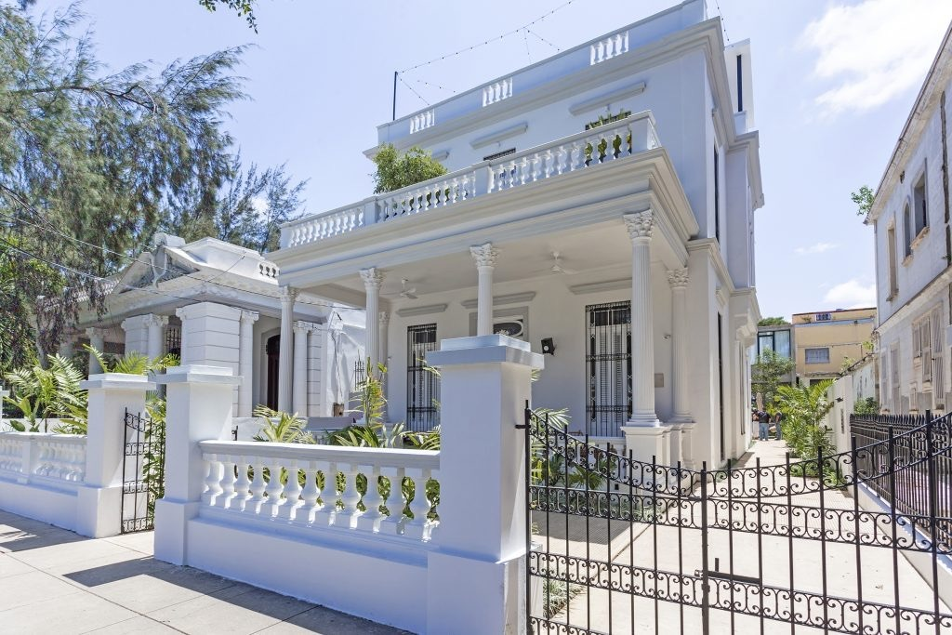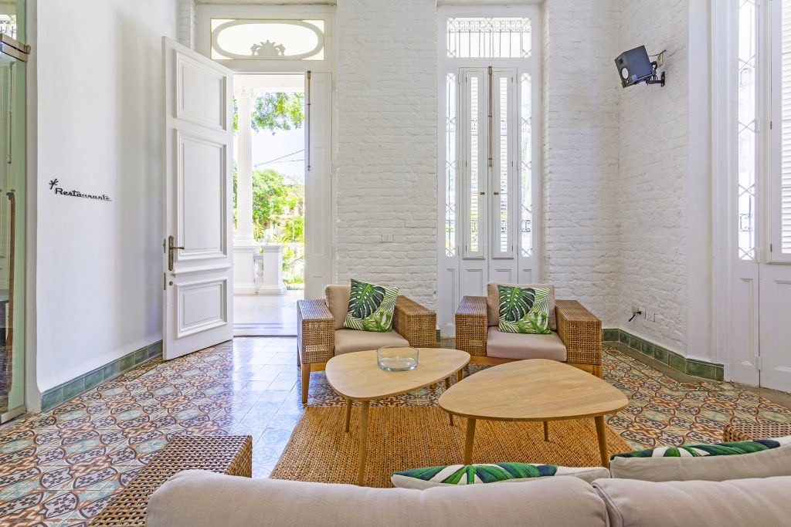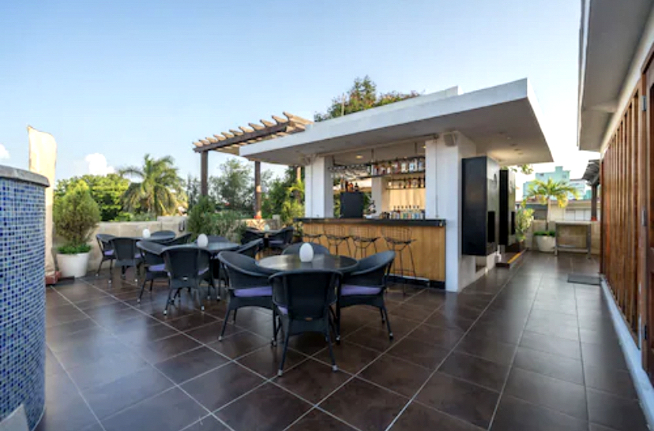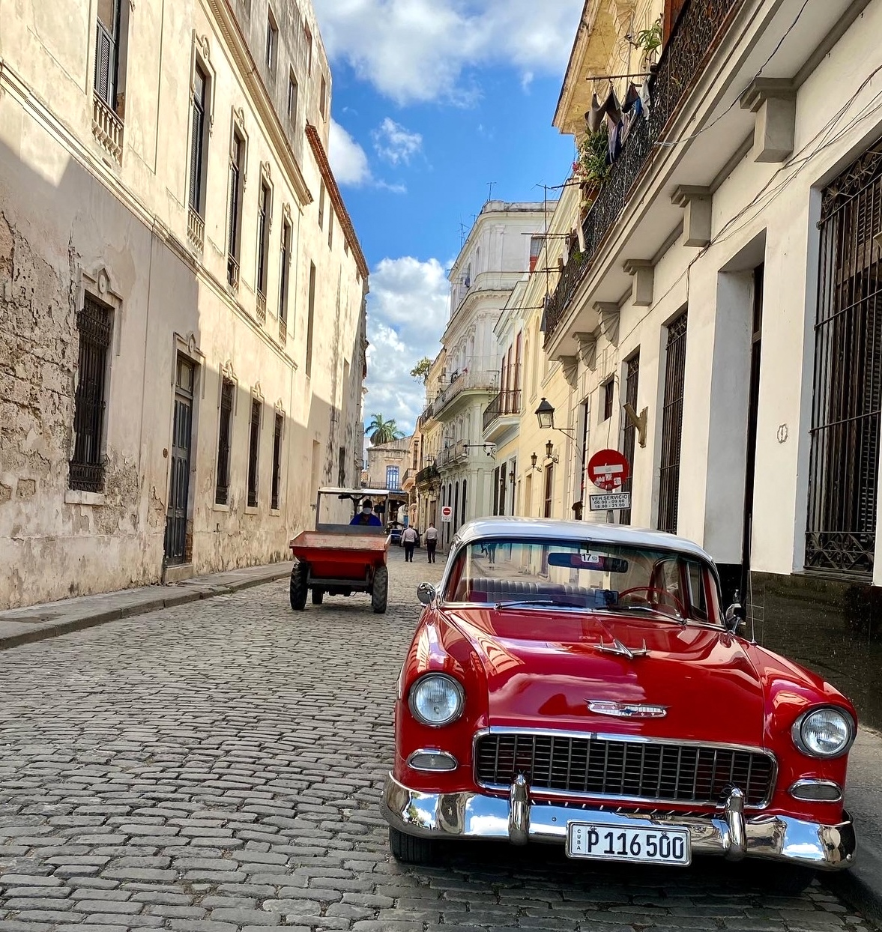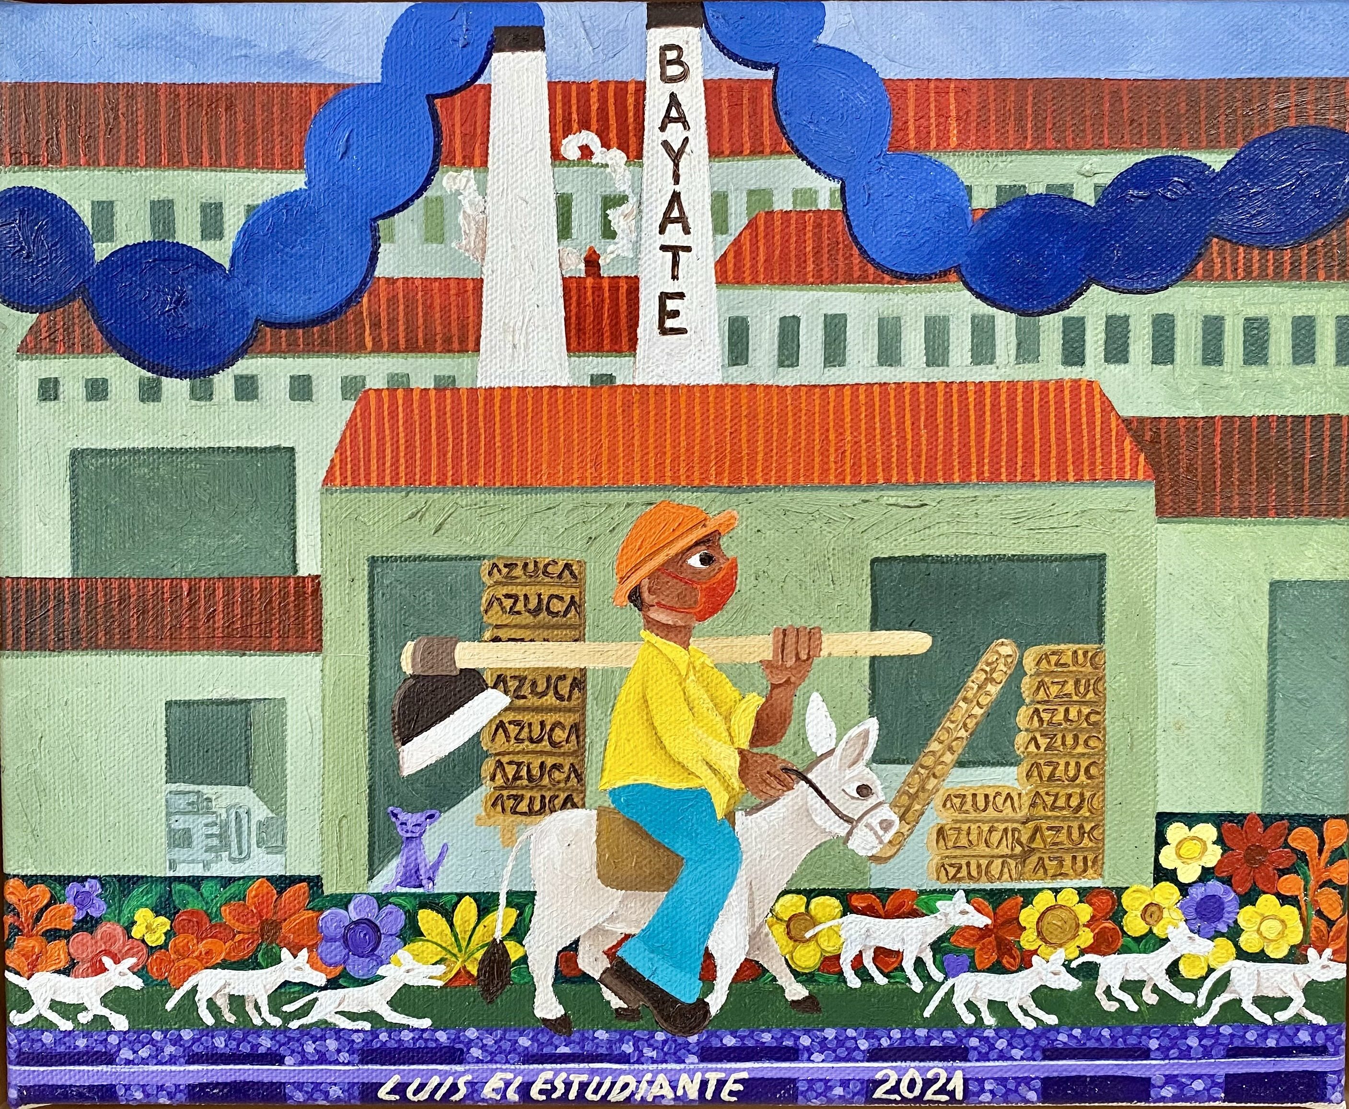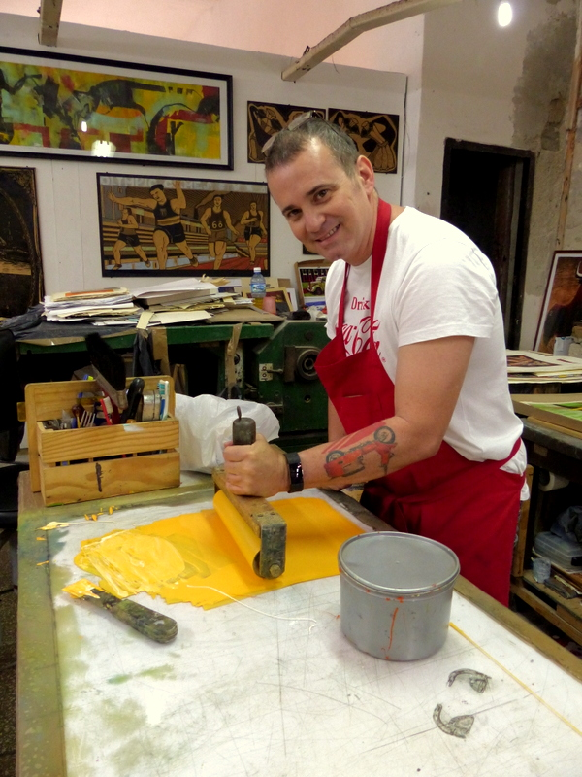

***Please note that itineraries are subject to change.***